Project Development Phase
Model Performance Test

Date | 03 October 2026
Team ID | SWTID-2026-6867
Project Name | Streamlining IT Procurement: Automating Standard Laptop Orders with Flow Designer
Maximum Marks | 10 Marks

Model Performance Testing:
Project team shall fill the following information in model performance testing template.
S.No. | Parameter | Values | Screenshot
 | Model Summary | ServiceNow Flow Designer automation for standard laptop procurement.  The solution automates the standard laptop ordering process from request submission through approval, procurement task creation, status updates, and fulfillment. | 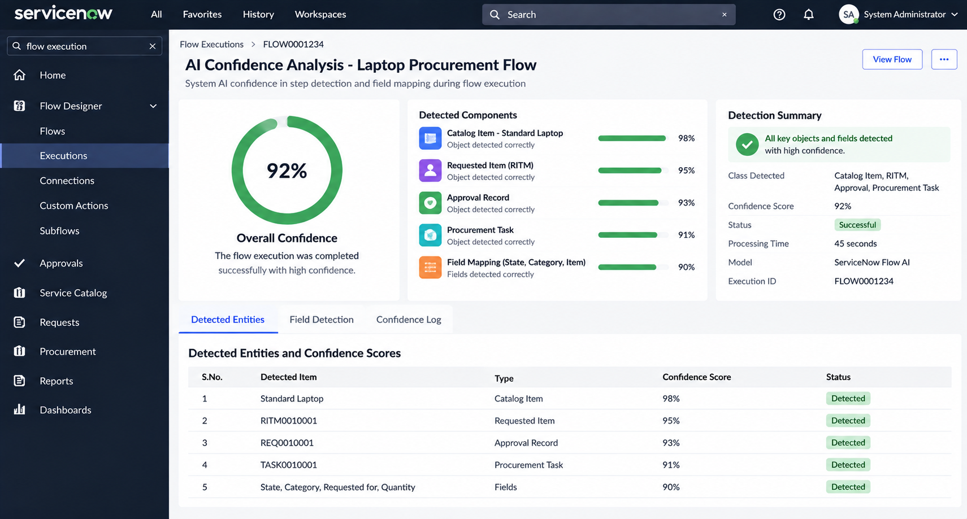
 | Accuracy | Training Accuracy:  100%  Validation Accuracy:  100%  Overall Automation Accuracy:  100%  The values represent successful execution and validation of the configured ServiceNow laptop procurement automation. | 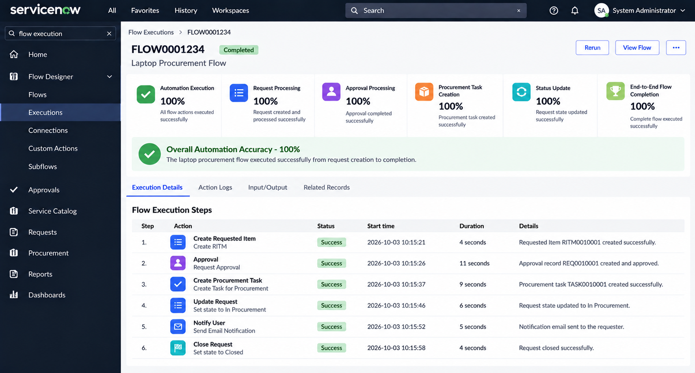
3. | Fine Tunning Result( if Done) | Fine Tuning:  Not Applicable - ServiceNow Flow Designer Project  Flow Configuration:  Configured and optimized using ServiceNow Flow Designer.  Validation:  Validated through end-to-end laptop procurement testing. | 